Installing CDK-Taverna 2

Note: Instructions for using CDK-Taverna 2 with Eclipse IDE and Windows 7

1. Install Maven 2

* Download/Installation instructions URL:

http://maven.apache.org/download.html#Installation

1. Install the Maven 2 plugin for Eclipse

* Plugin URL:

http://m2eclipse.sonatype.org/sites/m2e

1. Checkout CDK-Taverna 2 SVN repository:

* SVN repository URL:

https://cdktaverna2.svn.sourceforge.net/svnroot/cdktaverna2/trunk

1. 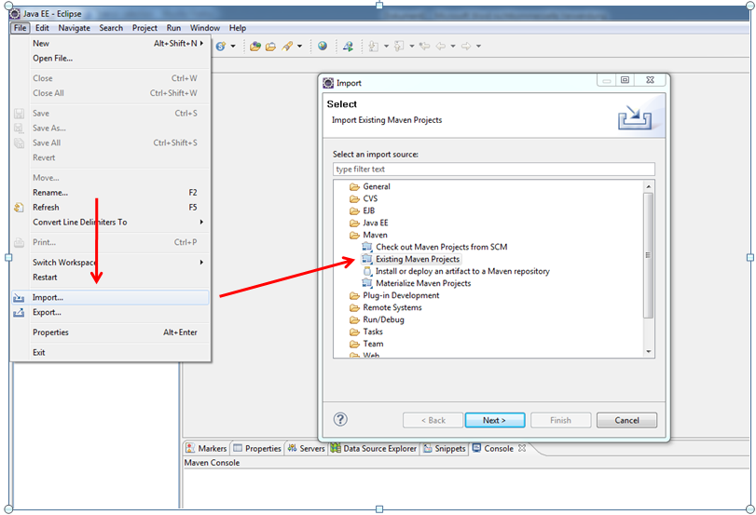Import Maven project to eclipse

Use the wizard to create a new project from the CDK-Taverna 2 root directory

1. Build project with Maven command line tool:

mvn –DskipTests=true clean install

It’s very important to skip the unit tests during the first build.

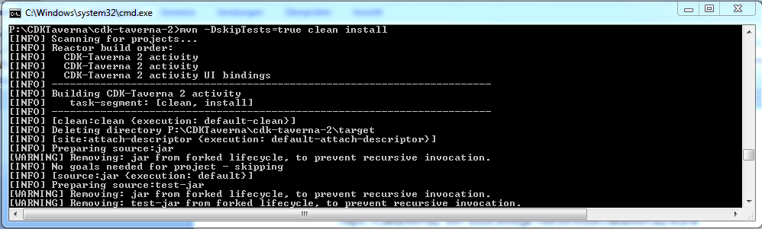

Retry step 5 when mvn command freezes

1. If Maven misses any dependencies compare the version in the pom files with the version of the missing ones. When the versions are different change the versions in the pom files and try again.
2. This time, rebuild the project using the maven command line tool with unit tests:

mvn clean install

1. If the build screen looks like this:

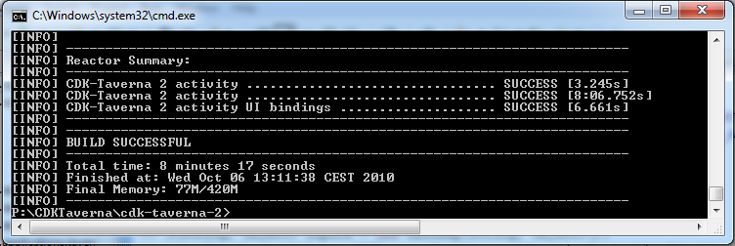

you were successful!

Running the Taverna debug workbench

To run the Taverna snapshot workbench left click on TavernaWorkbenchWithPlugin.java 🡪 Run As > Java Application

